<https://www.youtube.com/watch?v=NEaUSP4YerM&list=PLblh5JKOoLUICTaGLRoHQDuF_7q2GfuJF&index=32>

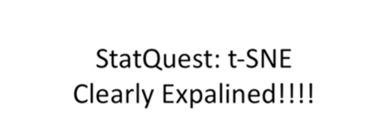

Today we're going to be talking about T-SNE or tis knee.

To be honest I don't actually know how it's pronounced but it's gonna be clearly explained.

I know that bet also this stack quest is by request a couple of people put it in the comments below and I got a couple of emails from other people so I'm doing it because you guys want it.

Here goes.

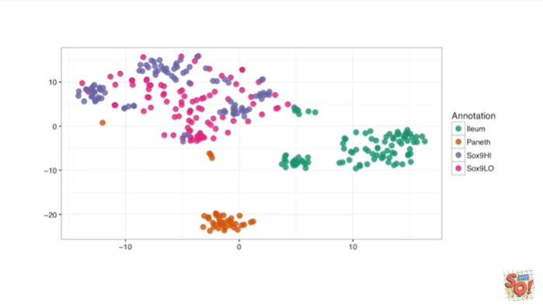

If you're watching this stack quest, chances are you've seen an example of a t-SNE graph before.

What t-SNE does is it takes a high dimensional data set and reduces it to a low dimensional graph that retains a lot of the original information.

If you're not familiar with those terms of taking a high dimensional data set and reducing it to a low dimensional graph, you might want to watch the stat quest for PCA, because i explain what that means in that video.

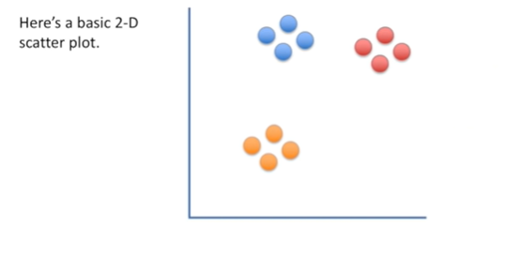

Here's a basic 2d scatter plot.

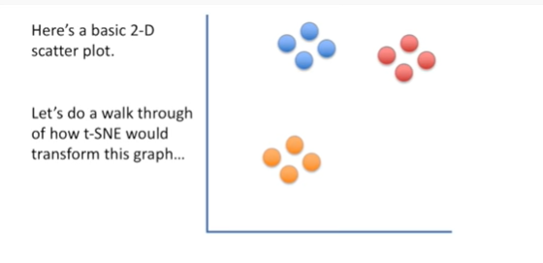

Let's do a walk through of how t-SNE would transform this graph

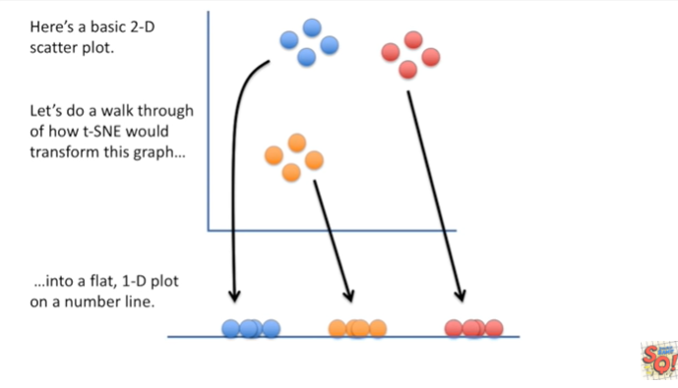

into a flat one dimensional plot on a number line.

I'm going to use this super simple example to explain the concepts behind t-SNE.

So that when you see it applied to a much larger data set a much more complex data set, you'll still know how that graph was drawn.

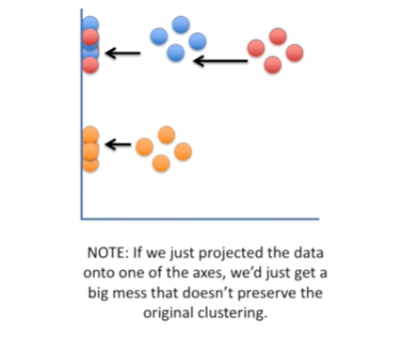

Note : if we just projected the data onto one of the axis, we just get a big mess that doesn't preserve the original clustering.

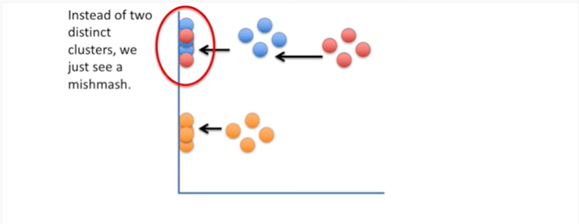

If we project it on to the y axis, instead of two distinct clusters we just see a mishmash.

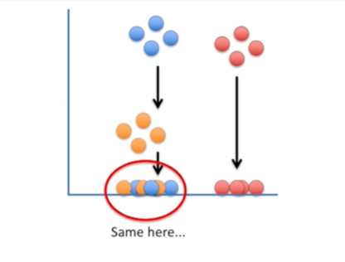

And the same thing happens if we just project the data onto the x axis.

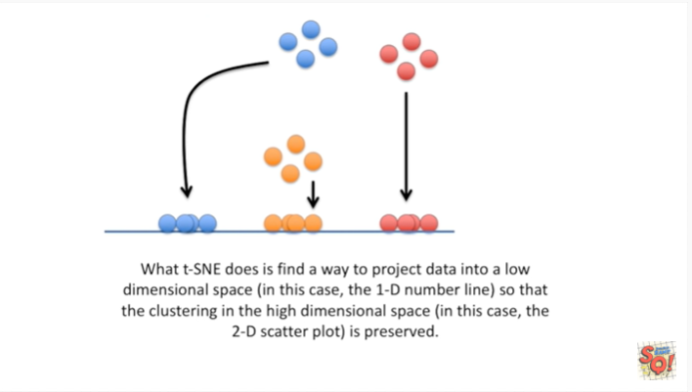

What T-SNE does is find a way to project data into a low dimensional space (in this case the one-dimensional number line) so that the clustering in the high dimensional space (in this case the 2-dimensional scatterplot) is preserved.

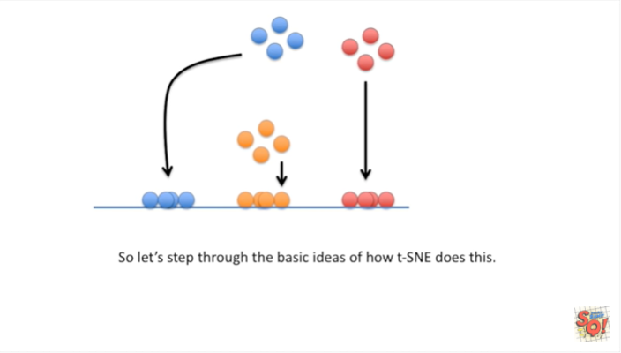

So let's step through the basic ideas of how t-+SNE does this.

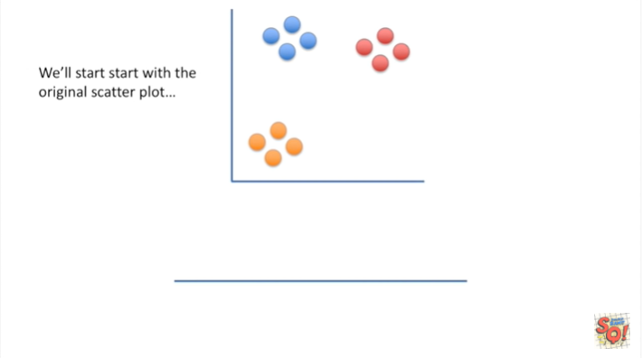

We'll start with the original scatter plot

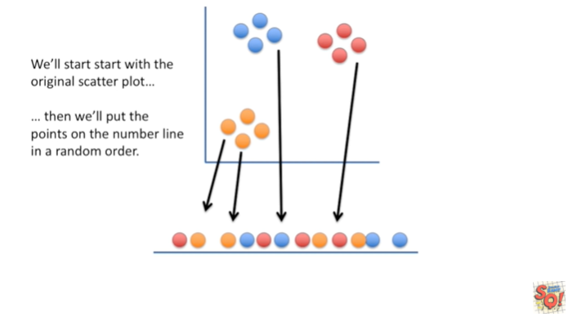

then we'll put the points on the number line in a random order.

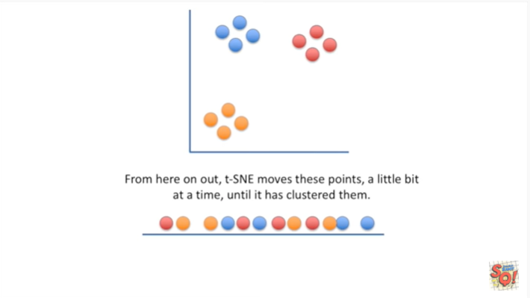

From here on out T-SNE moves these points a little bit at a time until it has clustered them.

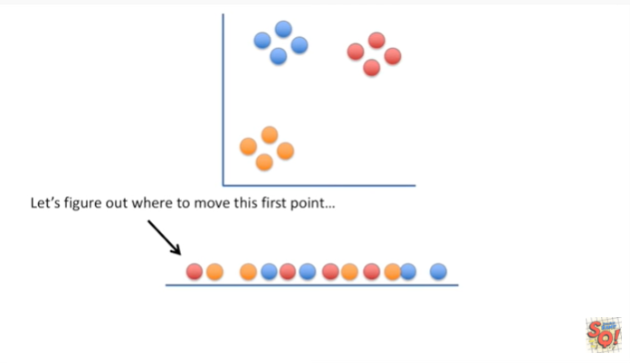

Let's figure out where to move this first point.

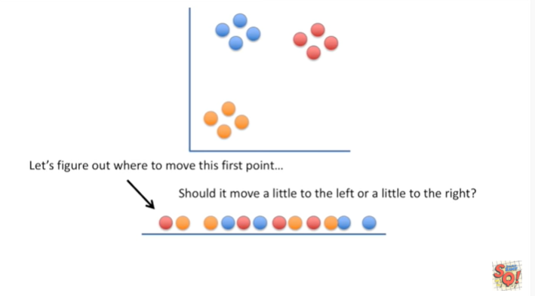

Should it move a little to the left or a little to the right ?

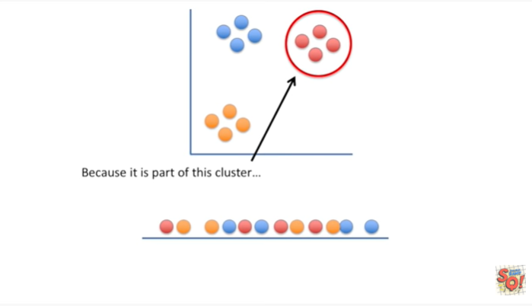

Because it is part of this cluster in the two-dimensional scatter plot

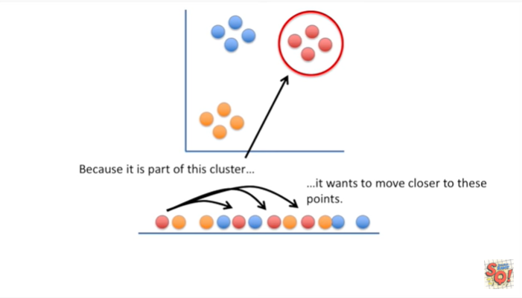

it wants to move closer to these points.

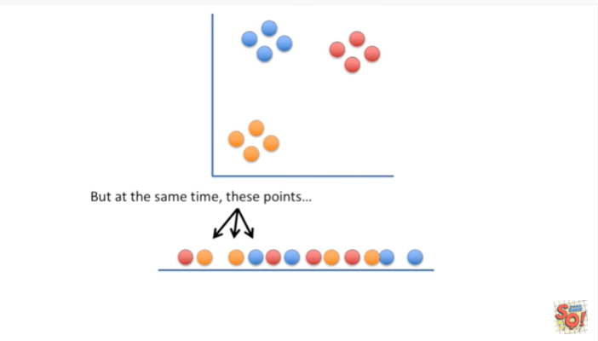

But at the same time these points

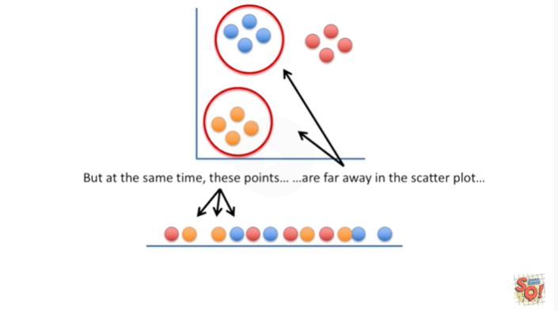

are far away in the scatter plot

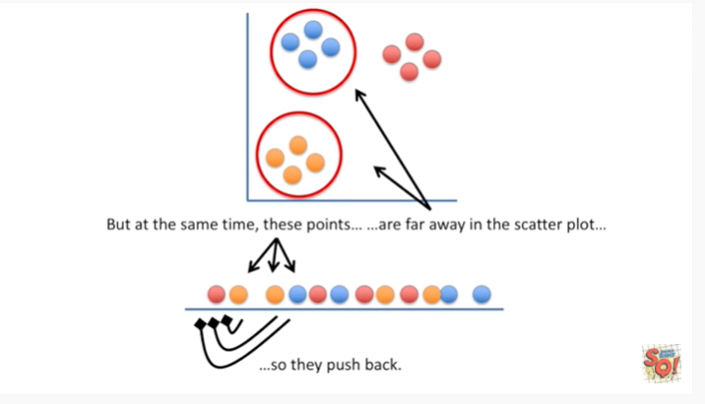

so they push back.

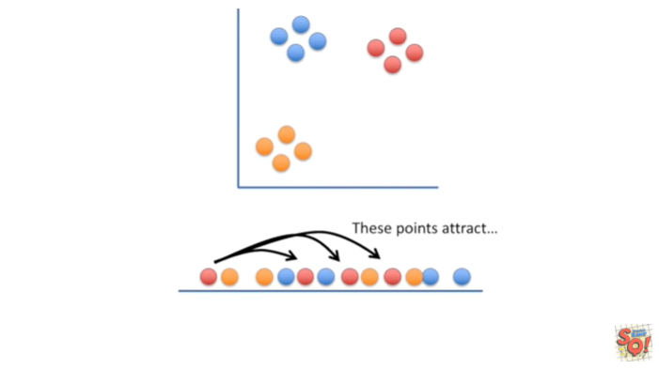

These points attract

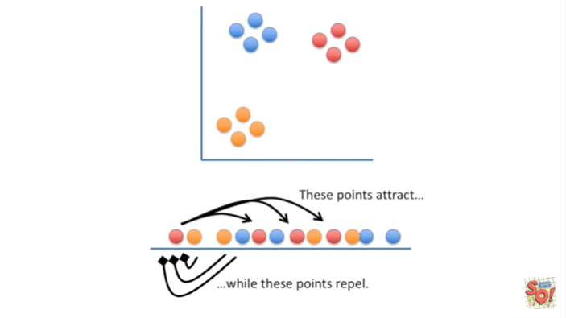

while these points repel.

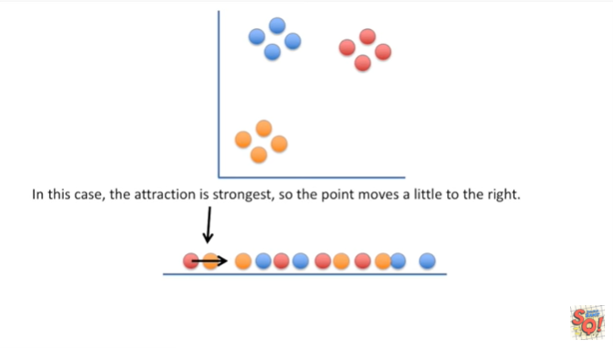

In this case the attraction is strongest, so the point moves a little to the right.

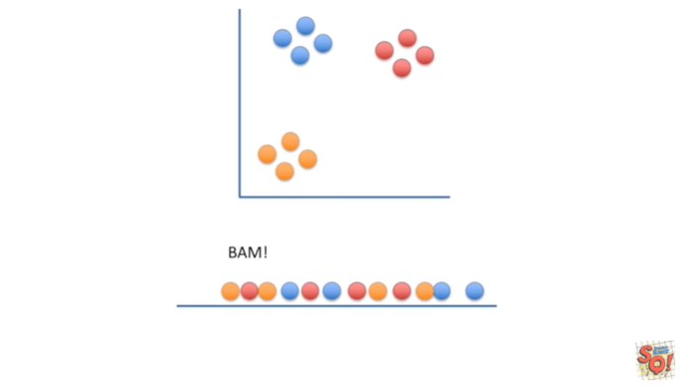

BAM !

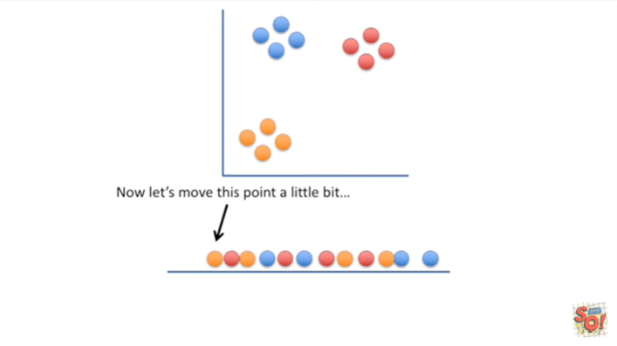

Now let's move this point a little bit.

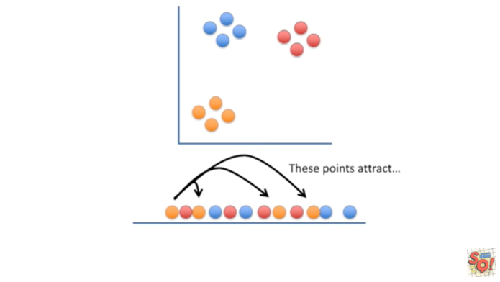

These points attract because they are close to each other in the two-dimensional scatter plot

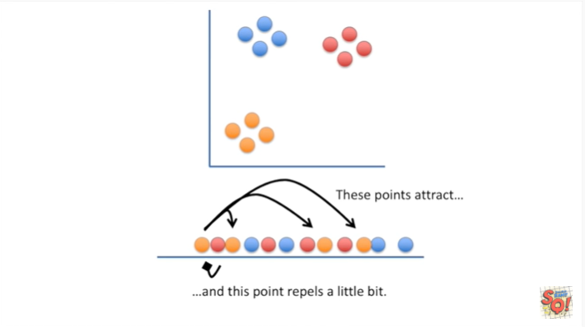

and this point repels a little bit because it is far from the point in the two-dimensional scatter plot.

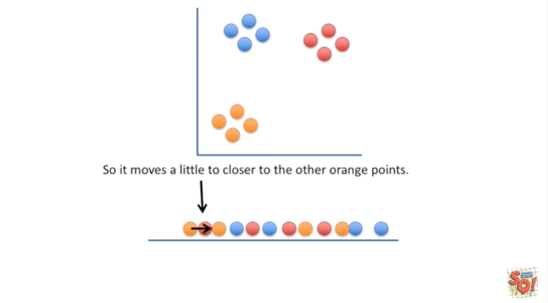

So it moves a little closer to the other orange points.

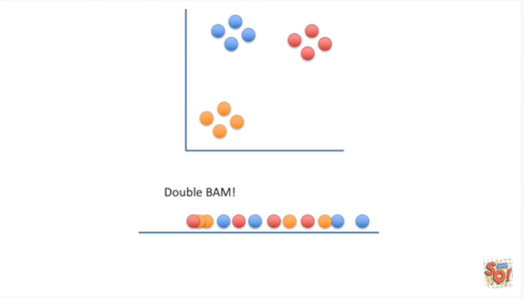

Double bam !!

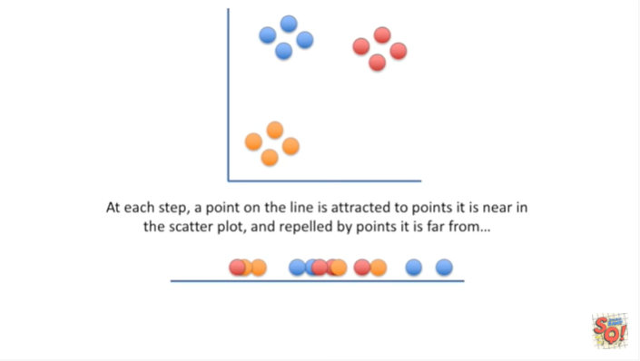

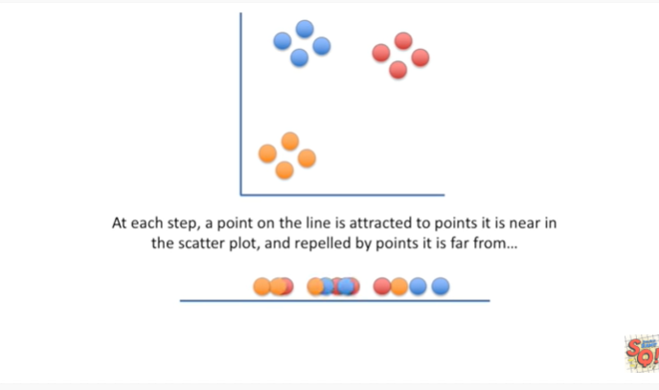

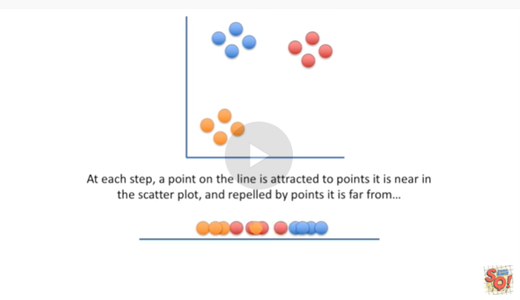

At each step a point on the line is attracted to points it is near in the scatterplot and repelled by points it is far from.

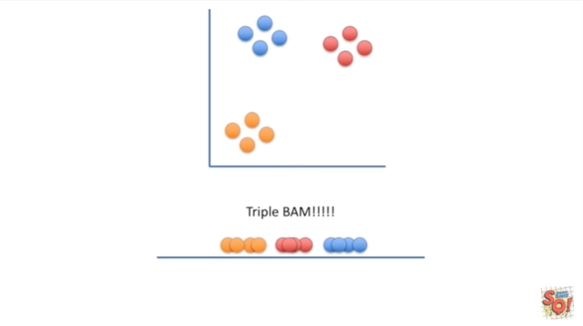

Triple BAM !!!!

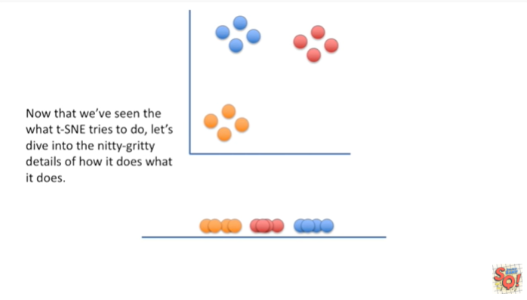

Now that we've seen what t-SNE tries to do, let's dive into the nitty-gritty details of how it does what it does.

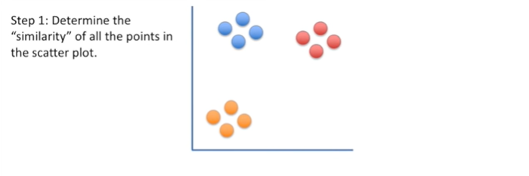

Step 1 : determine the similarity of all the points in the scatter plot.

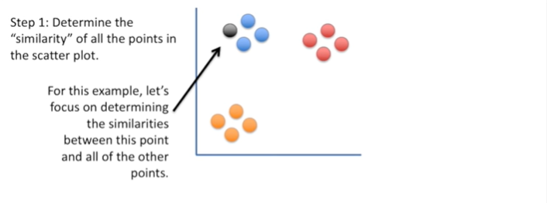

For this example, let's focus on determining the similarities between this point and all of the other points.

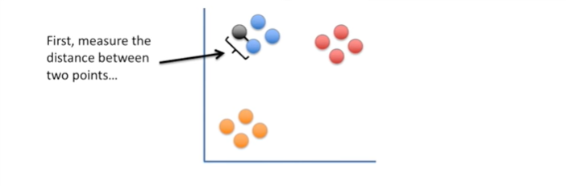

First measure the distance between two points

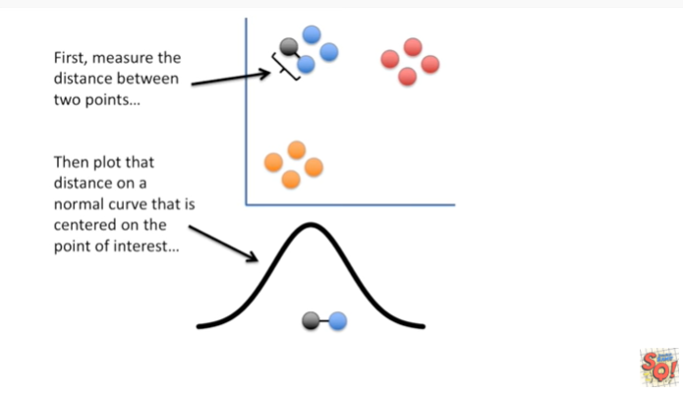

then plot that distance on a normal curve that is centered on the point of interest.

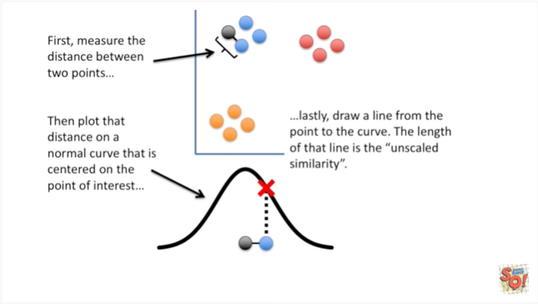

Lastly, draw a line from the point to the curve.

The length of that line is the unscaled similarity.

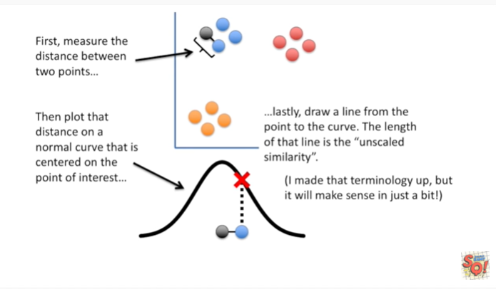

I made that terminology up but it'll make sense in just a bit, so hold on.

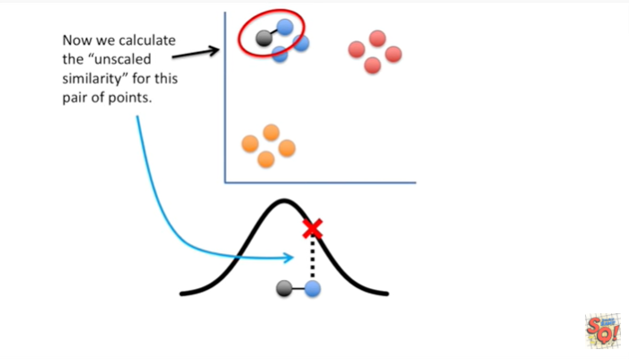

Now we calculate the unscaled similarity for this pair of points.

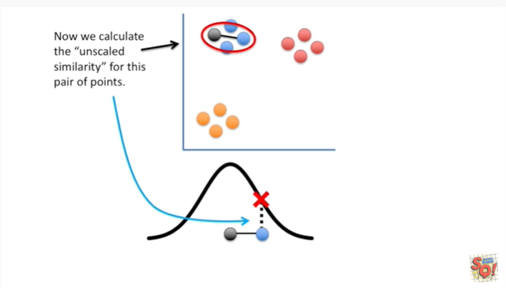

Now we calculate the unscaled similarity for this pair of points.

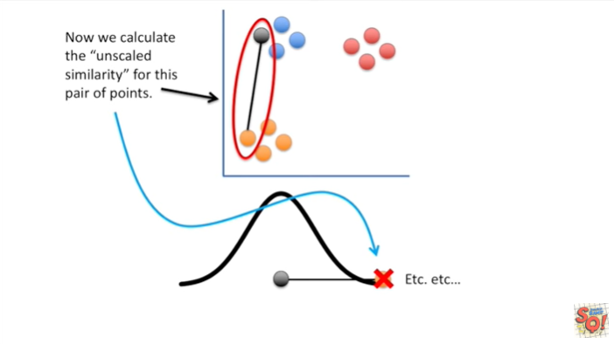

And now we calculate the unscaled similarity for this pair of points etc etc etc.

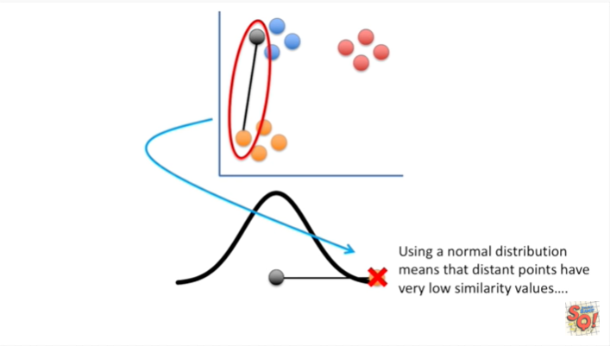

Using a normal distribution means that distant points have very low similarity values

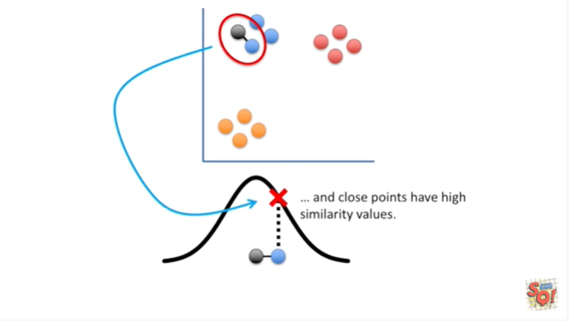

and close points have high similarity values.

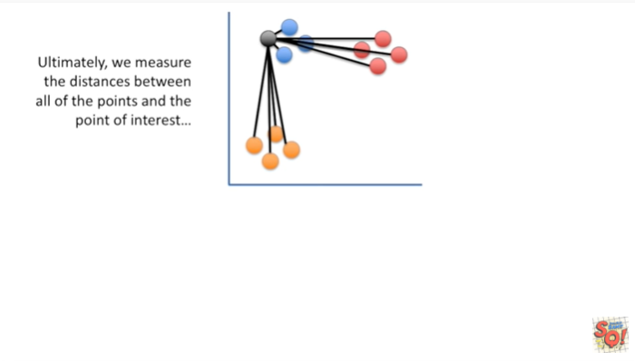

Ultimately we measure the distances between all of the points and the point of interest

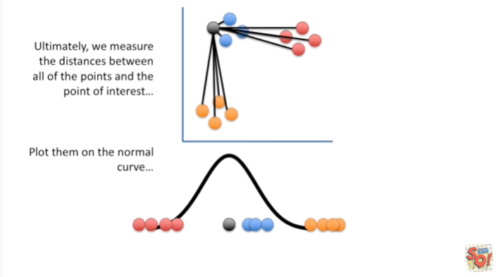

then plot them on a normal curve

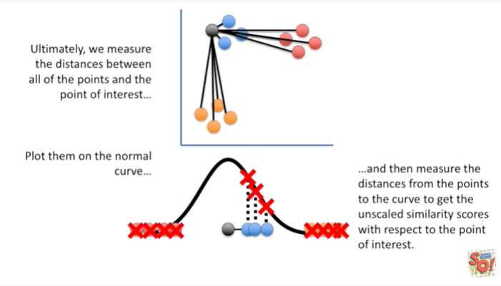

and then measure the distances from the points to the curve to get the unscaled similarity scores with respect to the point of interest.

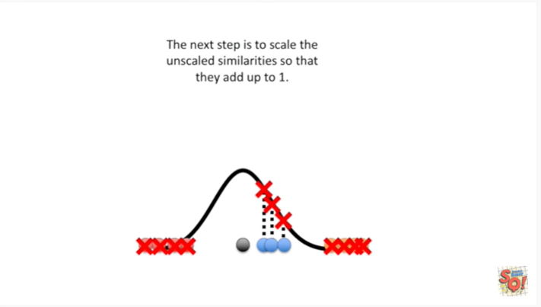

The next step is to scale the unscaled similarities so that they add up to 1 ?

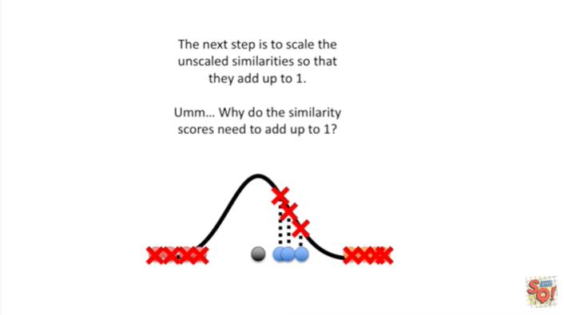

Hummm why do the similarity scores need to add up to 1 ?

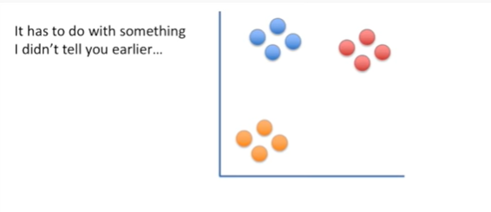

It has to do with something I didn't tell you earlier

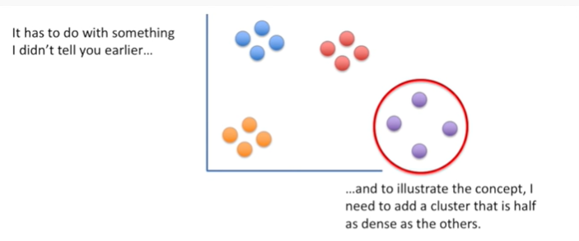

and to illustrate the concept I need to add a cluster that is half as dense as the others.

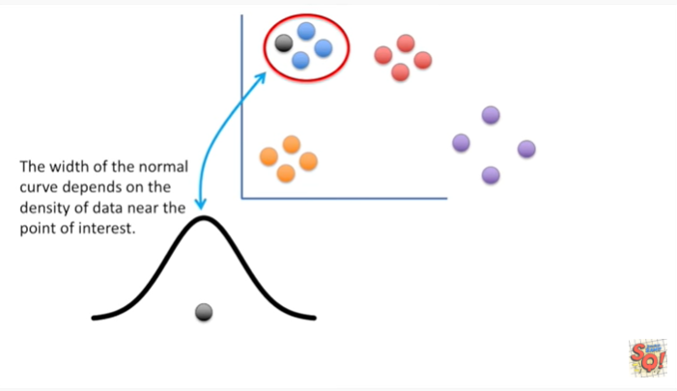

The width of the normal curve depends on the density of data near the point of interest.

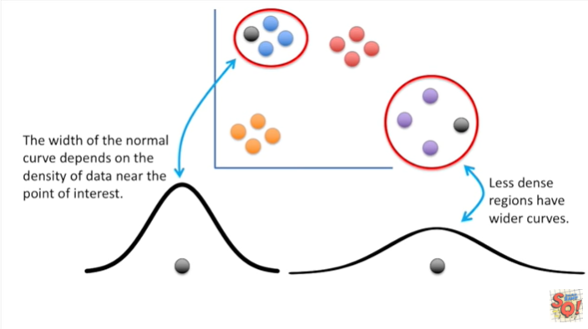

Less dense regions have wider curves

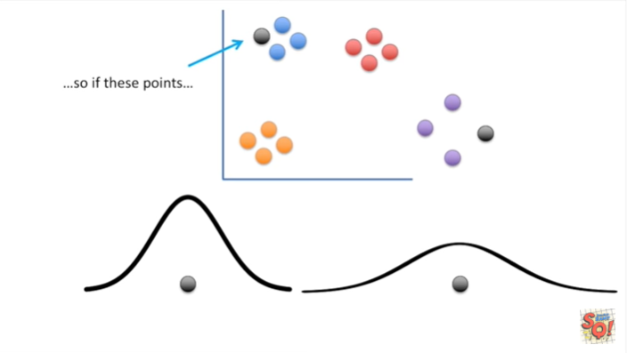

so if these points

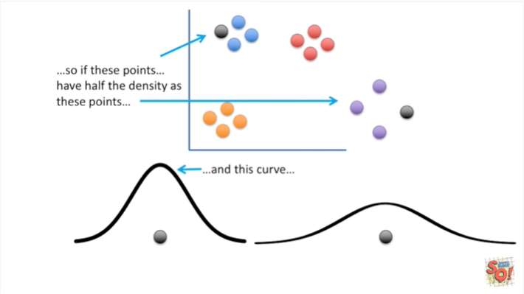

have 1/2 the density as these points

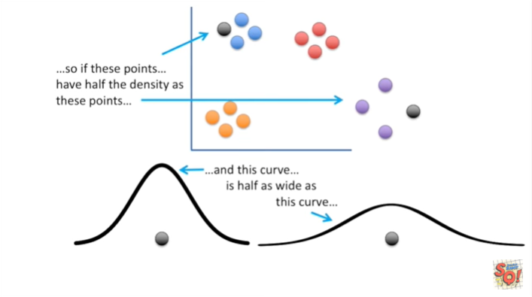

and this curve is half as wide as this curve

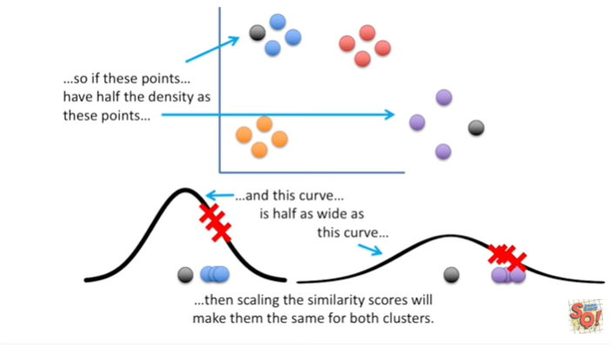

then scaling the similarity scores will make them the same for both clusters.

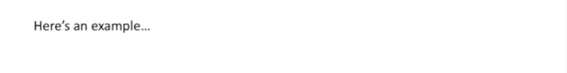

Here's an example where I've worked out the math.

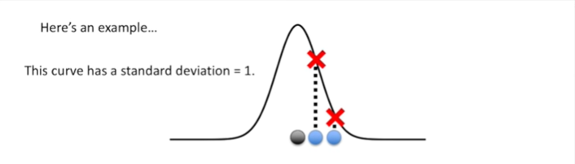

This curve has a standard deviation equal to 1.

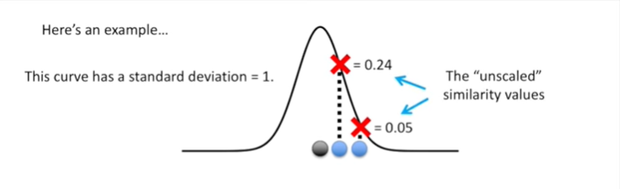

These are the unscaled similarity values.

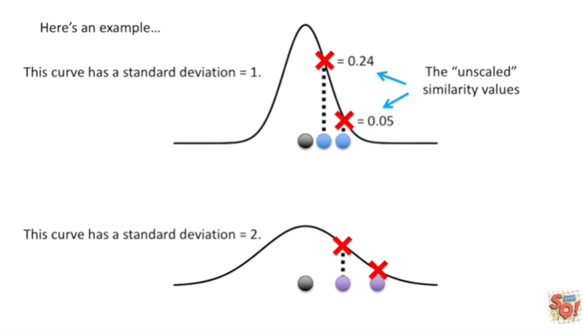

This curve has a standard deviation equal to 2.

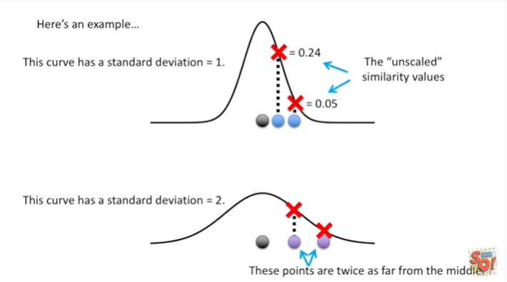

These points are twice as far from the middle.

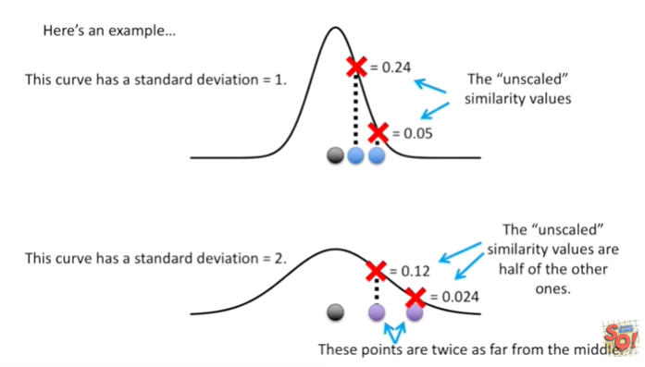

The unscaled similarity values are half of the other ones.

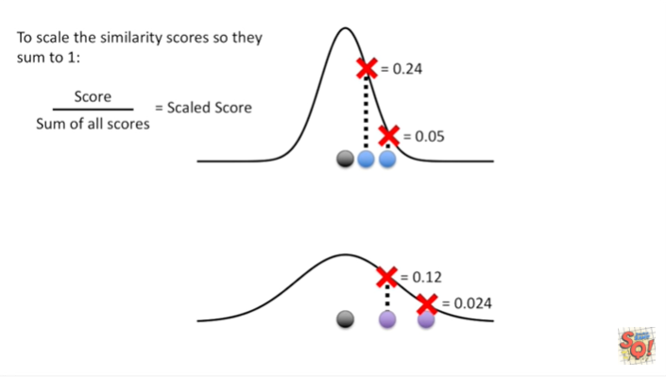

To scale the similarity scores so that they sum to one you take a score and you divided by the sum of all the scores that equals the scaled score.

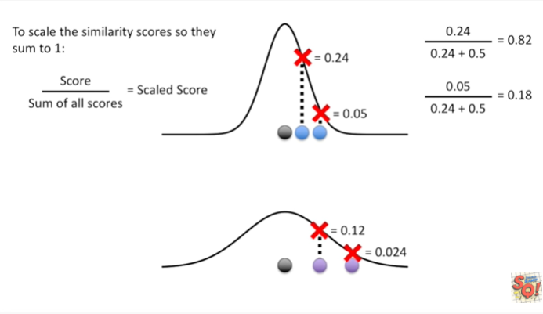

Here's how the math works out when the distribution has a standard deviation equals to one.

We get zero point eight two and zero point one eight as the scaled similarity scores.

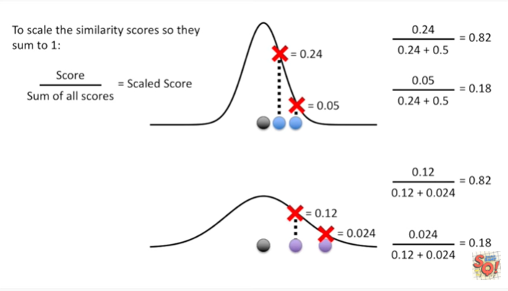

And here's the math for when everything is spread out twice as much.

We get zero point eight two and zero point one eight.

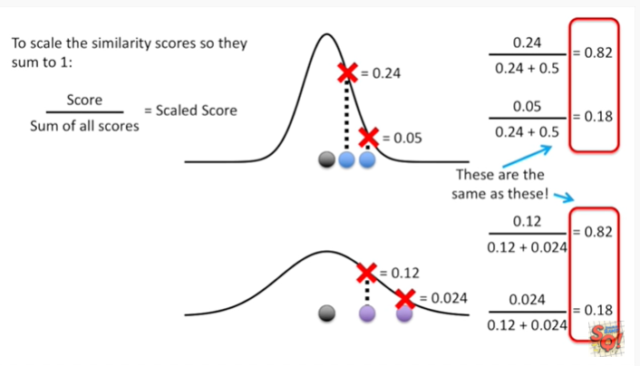

The similarity scores on top are equal to the similarity scores below.

They are the same !

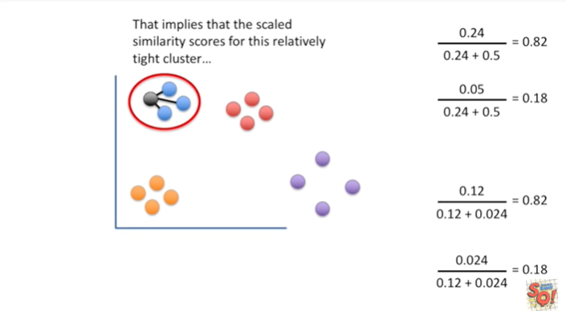

That implies that the scaled similarity scores for this relatively tight cluster

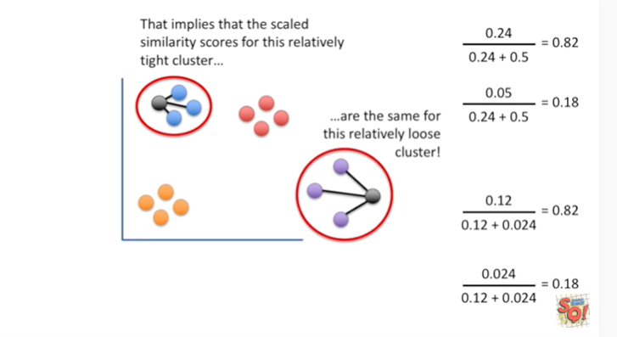

are the same for this relatively loose cluster.

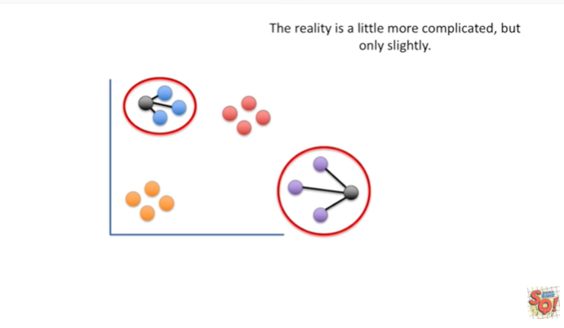

The reality is a little more complicated but only slightly.

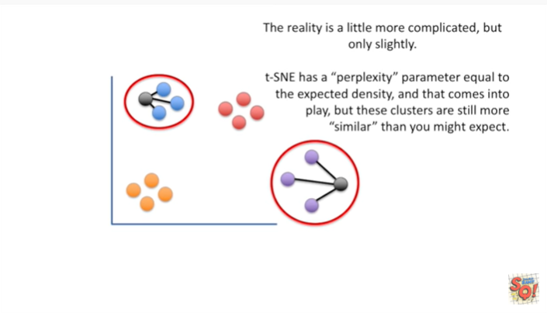

T-SNE has a perplexity parameter equal to the expected density around each point, and that comes into play but these clusters are still more similar than you might expect.

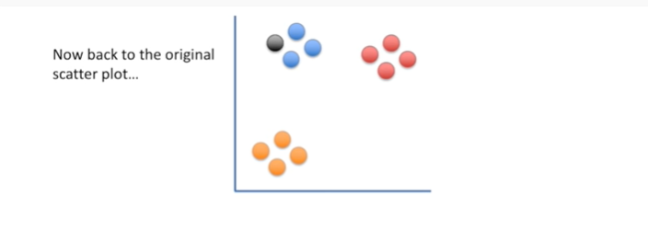

Now back to the original scatter plot.

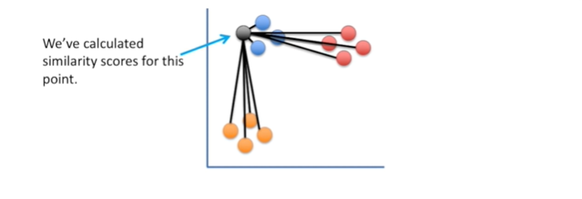

We've calculated similarity scores for this point.

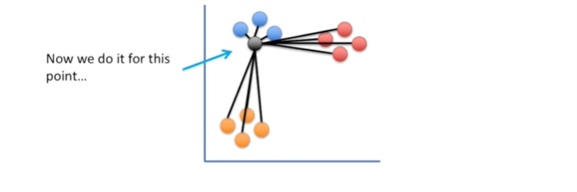

Now we do it for this point

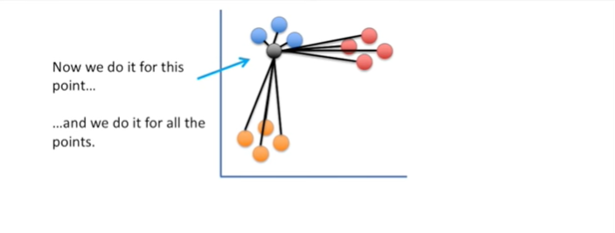

and we do it for all the points.

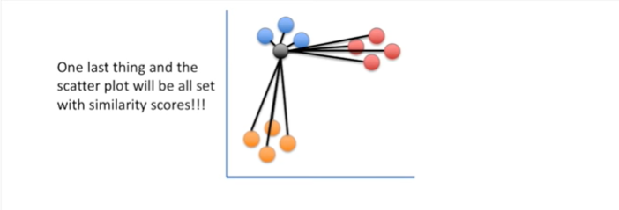

One last thing and the scatter plot will be all set with similarity scores !!!

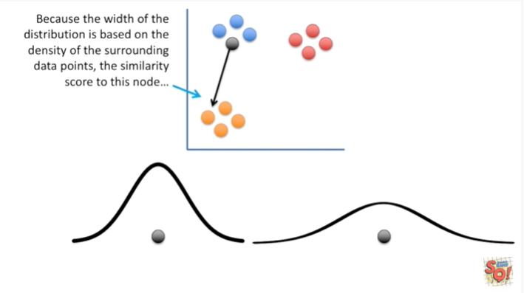

Because the width of the distribution is based on the density of the surrounding data points the similarity score for this node

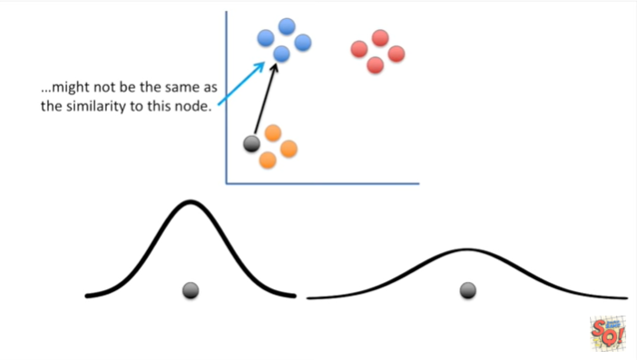

might not be the same as the similarity to this node.

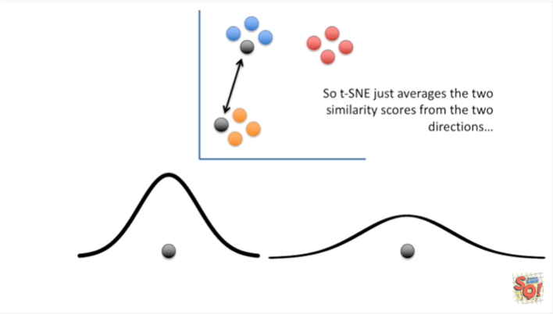

So T-SNE just averages the two similarity scores from the two directions.

No big deal !

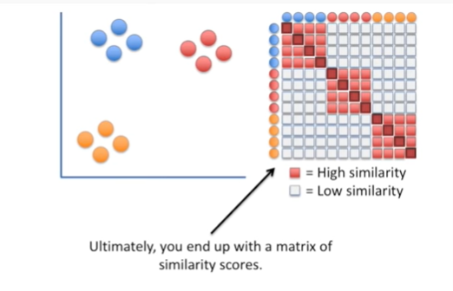

Ultimately you end up with a matrix of similarity scores.

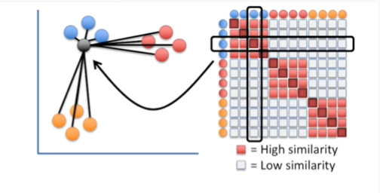

Each row and column represents the similarity scores calculated from that point of interest.

le red equals high similarity and white equals low similarity.

I've drawn the similarity from a point of interest to itself as dark red.

However it doesn't really make sense to say that a point is similar to itself because that doesn't help the clustering.

So t-SNE actually defines that similarity as zero.

Hooray were done calculating similarity scores for the scatter plot.

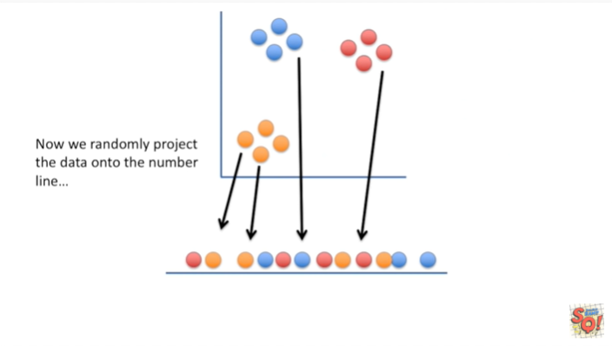

Now we randomly project the data onto the number line

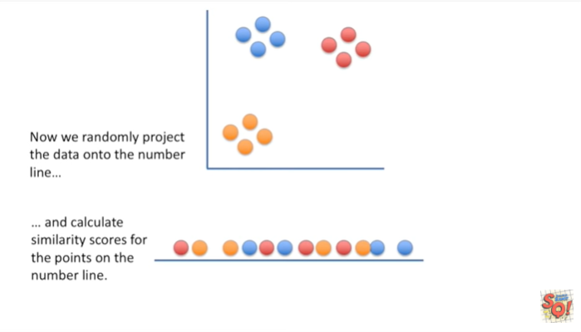

and calculate similarity scores for the points on the number line.

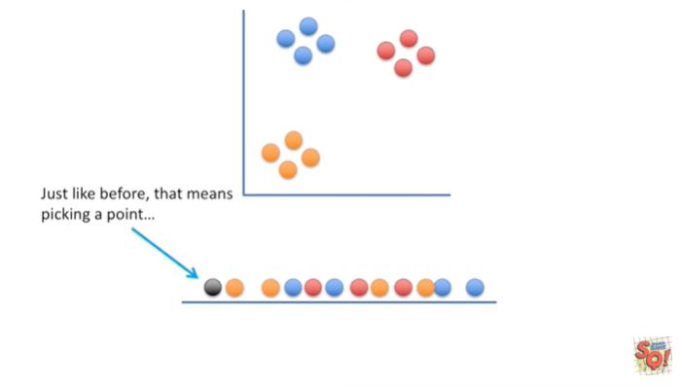

Just like before that means picking a point

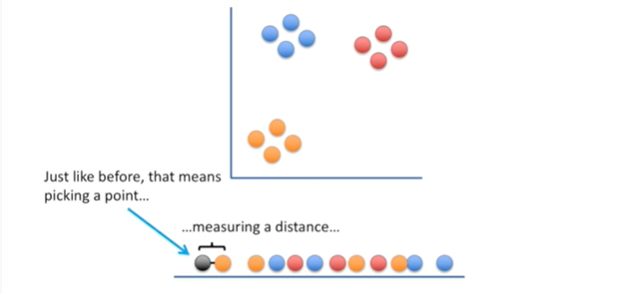

measuring a distance

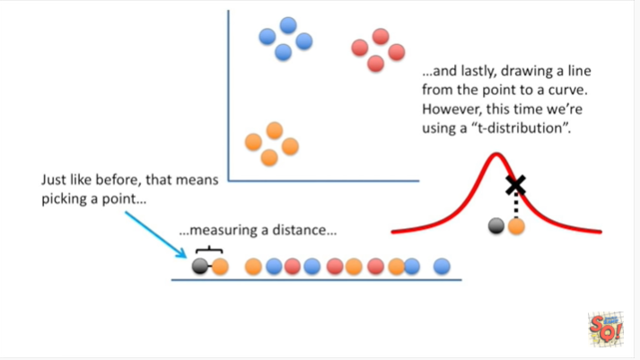

and lastly, drawing a line from the point to a curve.

However this time we're using a t-distribution.

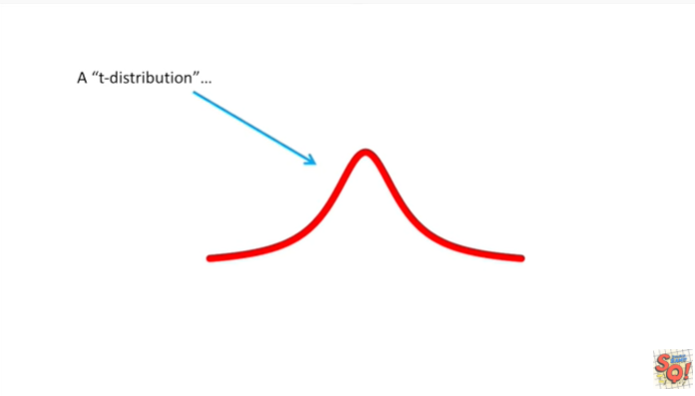

A t-distribution

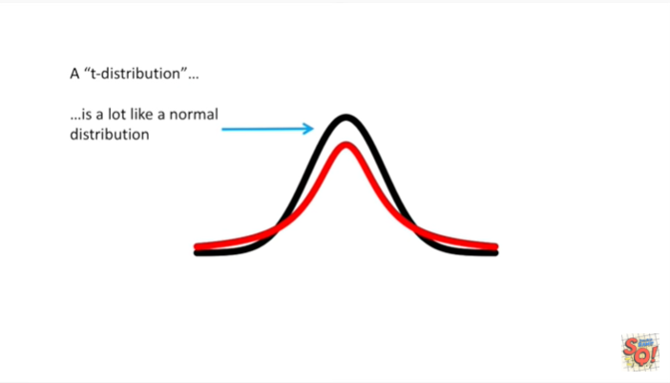is a lot like a normal distribution

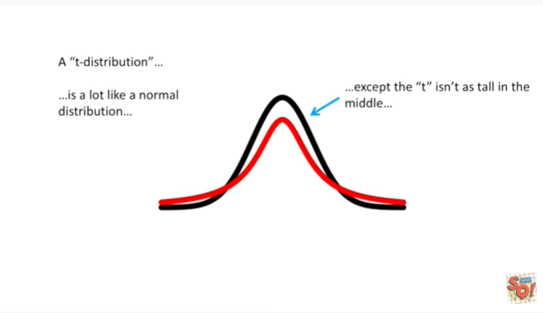

except the t isn't as tall in the middle

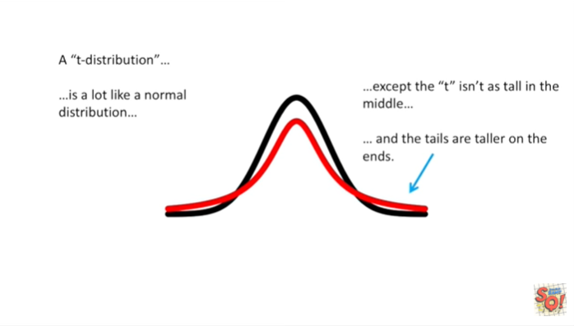

and the tails are taller on the ends.

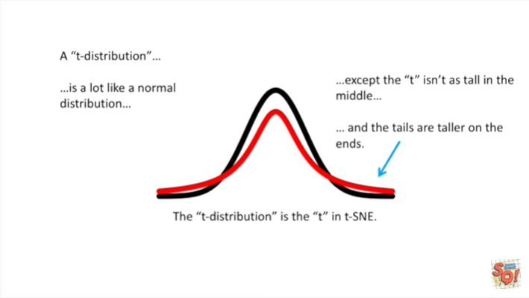

The t-distribution is the t in t-SNE.

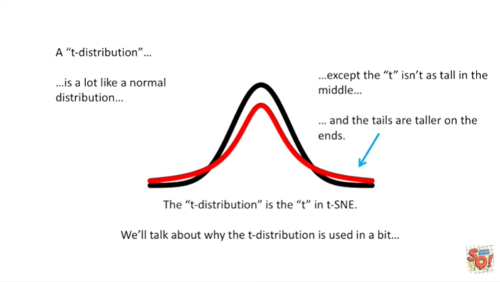

We'll talk about why the t-distribution is used in a little bit.

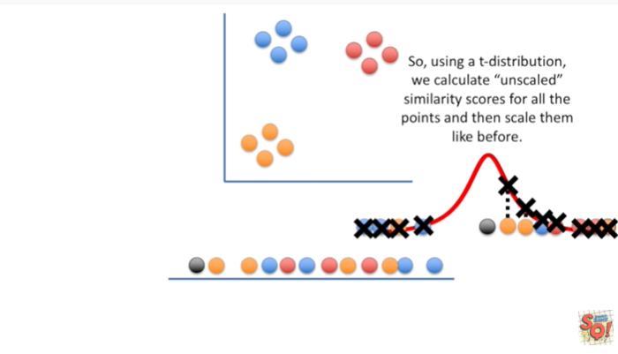

So using a t-distribution we calculate unscaled similarity scores for all the points and then scale them like before.

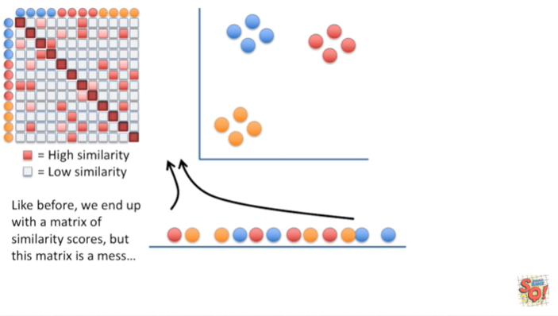

Like before we end up with a matrix of similarity scores but this matrix is a mess

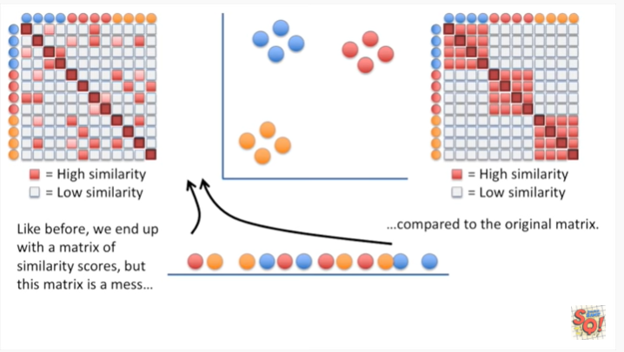

compared to the original matrix.

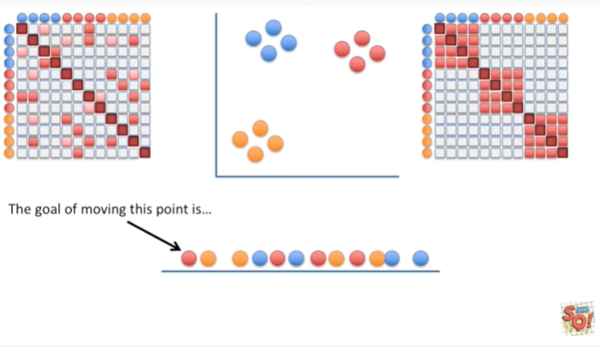

The goal of moving this point is

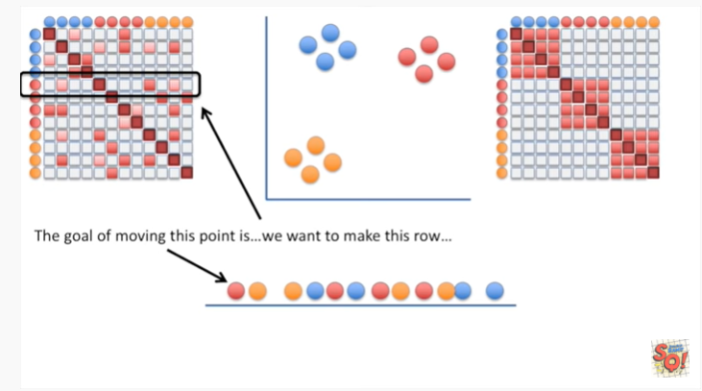

we want to make this row

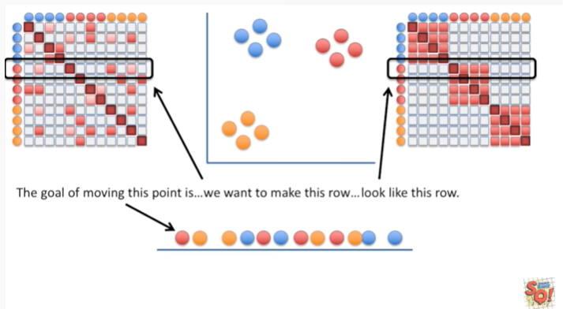

look like this row.

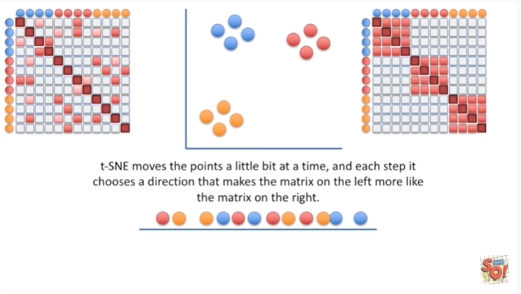

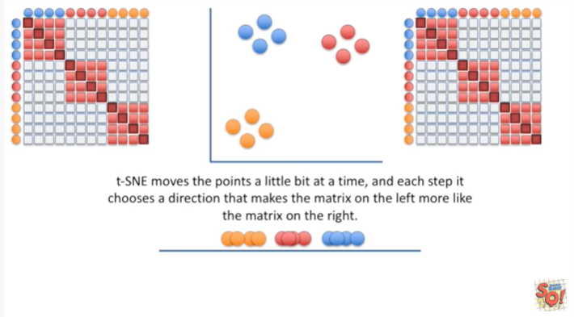

T-SNE moves the points a little bit at a time edit each step it chooses a direction that makes the matrix on the left more like the matrix on the right.

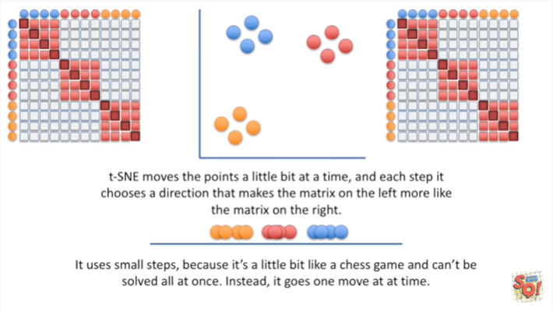

It uses small steps because it's a little bit like a chess game and can't be solved all at once.

Instead, it goes one move at a time.

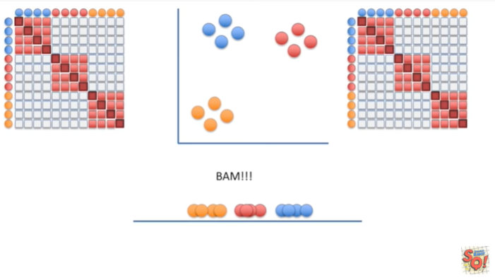

BAM !!!

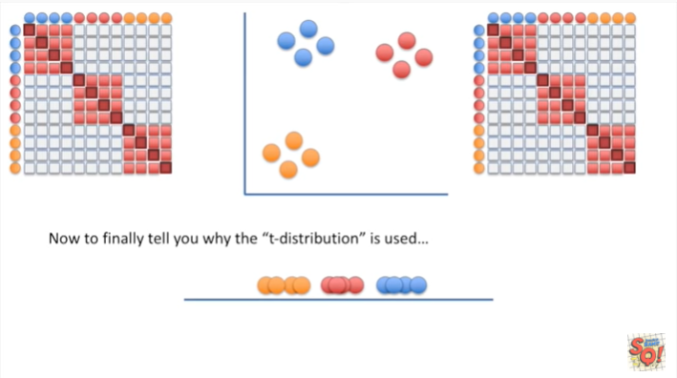

Now to finally tell you why the t-distribution is used

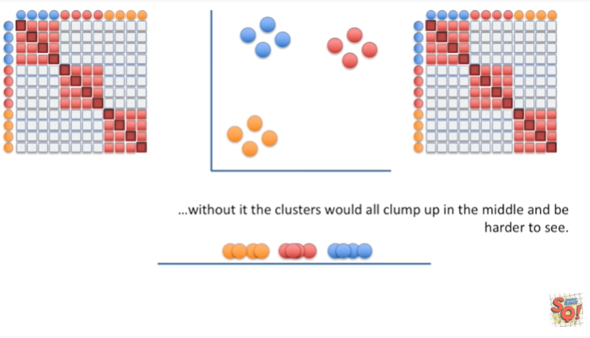

without it the clusters would all clump up in the middle and be harder to see.

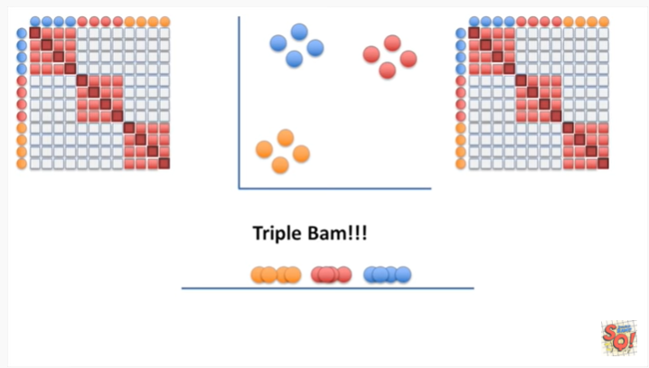

Triple bam !!!

And now we know how t-SNE works.

I've used a really simple example here but the concepts are the exact same for more complicated data sets.